**Web Application for Quantifying Carbon Footprint in Indian Coal Mines Using MERN Stack**

**Objectives**:

* Quantify carbon emissions from coal mining activities.
* Estimate carbon sinks and calculate gaps.
* Provide pathways to achieve carbon neutrality.

**Features**:

* Emission Estimation Module
* Carbon Neutrality Pathways Module
* Data Visualization
* Scalability for different mine sizes and types.

**Technologies:**

**Frontend Development**

* **Technologies**: React.js, Redux (for state management), Chart.js/D3.js (for data visualization)
* **Components**:
  + **Dashboard**: Overview of carbon footprint, emission trends, and pathways to neutrality.
  + **Data Input Forms**: Forms for users to input mining activity data (e.g., equipment usage, excavation volumes).
  + **Results Visualization**: Charts/graphs to display emission estimates, carbon sinks, and potential reduction strategies.
  + **Pathway Simulator**: UI to simulate different carbon neutrality strategies (clean technologies, afforestation, etc.).

**3. Backend Development**

* **Technologies**: Node.js, Express.js
* **API Endpoints**:
  + **/api/emission-calculate**: Calculate carbon emissions based on input data.
  + **/api/carbon-sink**: Estimate current carbon sinks based on land area and tree density.
  + **/api/pathways**: Provide pathways for carbon neutrality based on user input and simulation data.
  + **/api/carbon-credits**: Estimate potential carbon credits based on emission reduction and market rates.

**Algorithms**:

* **Emission Estimation**:
  + Formula: Total Emissions = ∑ (Activity Data × Emission Factor)
  + **Activity Data**: Input from users about mining activities (e.g., diesel consumption, electricity usage).
  + **Emission Factors**: Pre-defined constants based on established guidelines for each activity.
* **Carbon Sink Estimation**:
  + Formula: Carbon Sequestration = Area of Land × Tree Density × Sequestration Rate
  + **Sequestration Rate**: Pre-defined values based on tree species and age.
* **Carbon Neutrality Pathways**:
  + **Clean Technologies**: Calculate emission reduction from electric vehicles, methane capture, etc.
  + **Afforestation**: Estimate land required for offsetting emissions through tree planting.
  + **Alternative Energy**: Assess the impact of using renewable energy (solar, wind) on emissions.

**Database Structure**

* **Technologies**: MongoDB
* **Schema Design**:
  + **Mines Collection**:
    - mineId: Unique identifier
    - mineType: Underground or Open-cast
    - location: Geographical data
    - size: Size of the mine (small, medium, large)
  + **Emissions Collection**:
    - emissionId: Unique identifier
    - mineId: Reference to Mines collection
    - activityType: Type of activity (excavation, transportation, etc.)
    - activityData: Data specific to the activity
    - emissionValue: Calculated emission
  + **CarbonSinks Collection**:
    - sinkId: Unique identifier
    - mineId: Reference to Mines collection
    - landArea: Area of land available for afforestation
    - treeDensity: Number of trees per unit area
    - sequestrationRate: Carbon absorption rate
  + **Pathways Collection**:
    - pathwayId: Unique identifier
    - mineId: Reference to Mines collection
    - strategy: Type of strategy (clean tech, afforestation, etc.)
    - potentialReduction: Estimated emission reduction

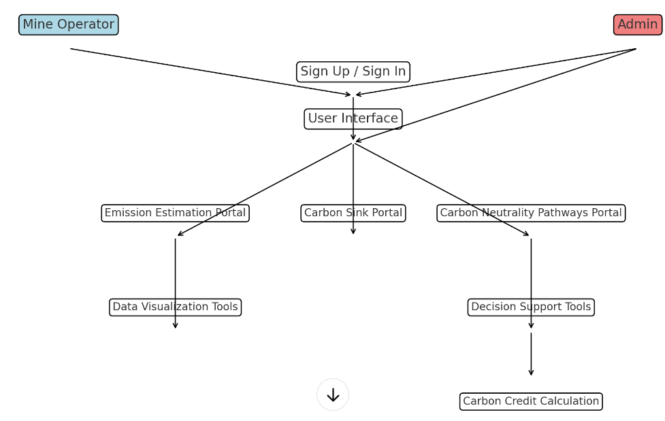

**Real-Life Example: Coal Mine XYZ**

Location: Eastern India

Size:5,000 hectares

Annual Coal Production:10 million tons

Employees:1,200

**Step-by-Step Process**

**1. Data Collection**

a. User Input

Fuel Consumption: The mine operator inputs that the machinery and vehicles used in the mining operations consume 500,000 liters of diesel annually.

Electricity Usage: The mine reports an annual electricity consumption of 10 million kWh.

Methane Emissions: The mine emits 2,000 tons of methane annually from coal seams.

Transportation Data:The transportation of coal and other materials consumes 200,000 liters of diesel annually.

Employee Travel: On average, each of the 1,200 employees travels 20 km daily using personal vehicles, with an average fuel efficiency of 15 km per liter.

- Waste Management:

**b. Calculation:**

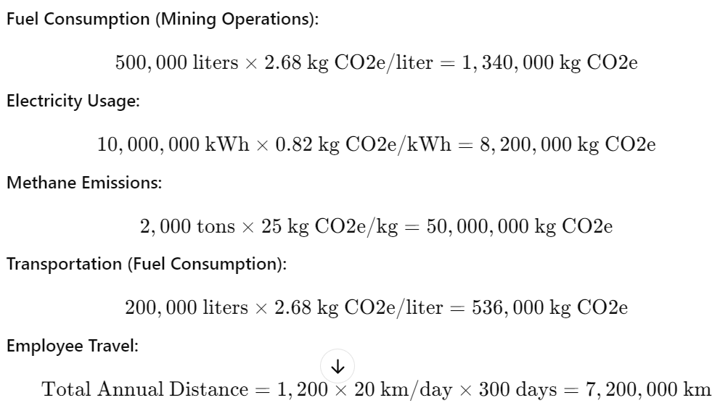

2. Emission Factor Calculation

a. Emission Factor Database:

- Diesel Fuel: The emission factor for diesel is 2.68 kg CO2e per liter.

- Electricity: The emission factor for grid electricity in India is 0.82 kg CO2e per kWh.

- Methane: The Global Warming Potential (GWP) of methane is 25 kg CO2e per kg.

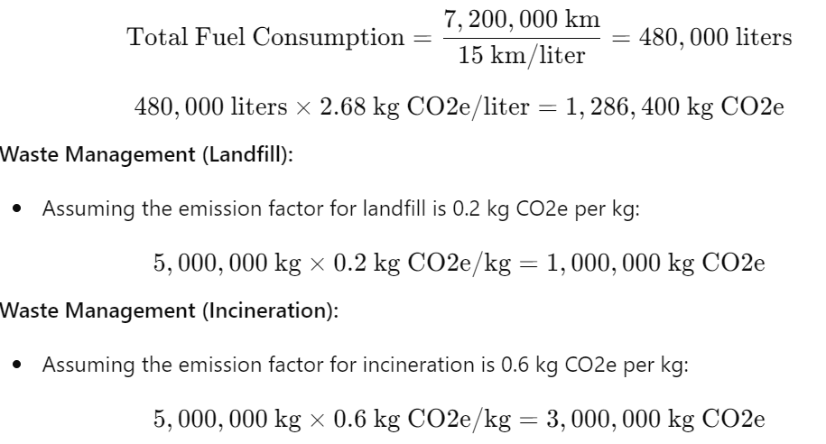

3. Activity-Wise Carbon Footprint Quantification

a. Categorization: Scope 1 Emissions (Direct):

- Fuel consumption for mining operations and transportation.

- Methane emissions from coal seams.

Scope 2 Emissions (Indirect): Electricity usage.

Scope 3 Emissions (Value Chain): Employee travel.Waste management

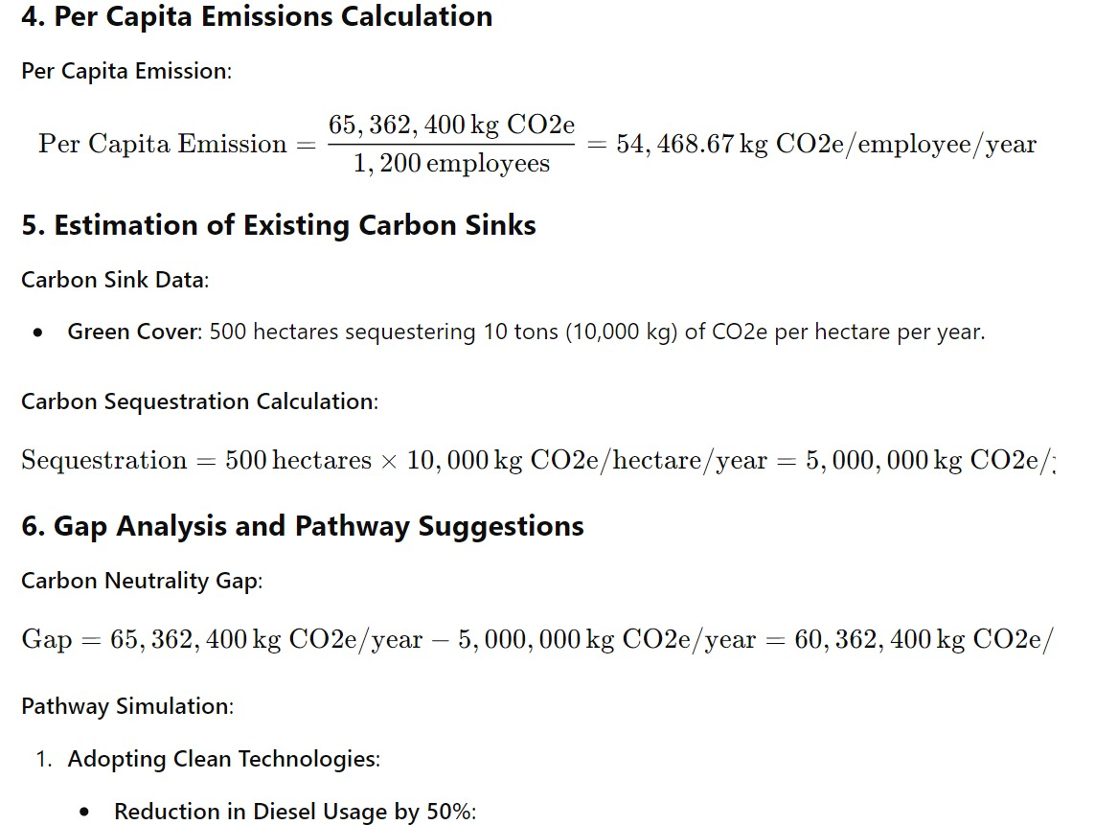

b. Dashboard:

- The dashboard provides a breakdown:

- Scope 1: 1,340,000 + 536,000 + 50,000,000 = 51,876,000 kg CO2e

- Scope 2: 8,200,000 kg CO2e

- Scope 3: 1,286,400 + 1,000,000 + 3,000,000 = 5,286,400 kg CO2e

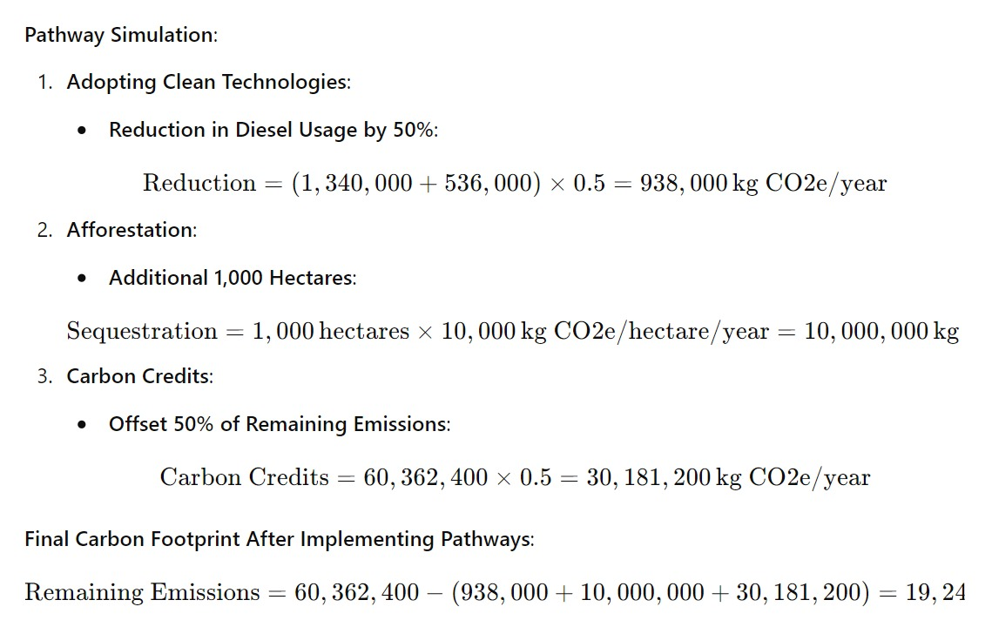

Total Carbon Footprint:

51,876,000 + 8,200,000 + 5,286,400 = 65,362,400 kg CO2e/year

- Emissions Reduction (Clean Technologies):

- 938,000 kg CO2e/year

-Additional Carbon Sequestration (Afforestation):

- 10,000,000 kg CO2e/year

- Carbon Credits:

- 30,181,200 kg CO2e/year

- Final Gap:

60,362,400 - (938,000 + 10,000,000 + 30,181,200) = 19,243,200 \text{ kg CO2e/year}